

Digital Logic Design

LAB - 02

Basic Logic Gates

* Student ID: k224779
* Student name: Muhammad Bilal

**Lab Task #1**

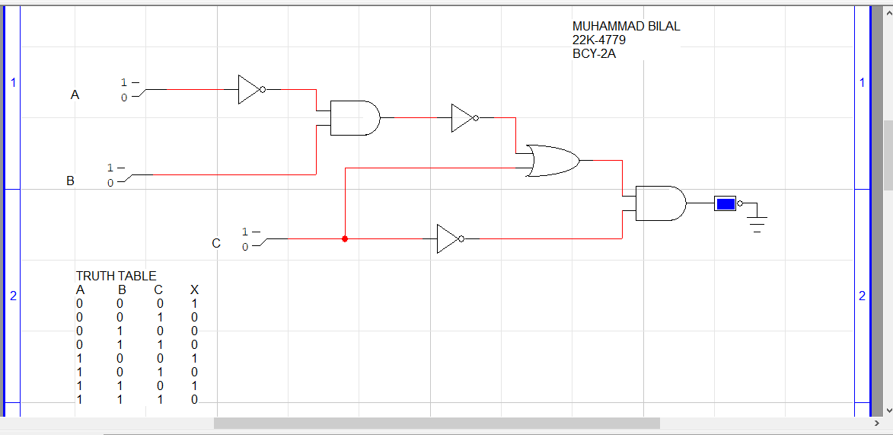

**Lab Task #2**

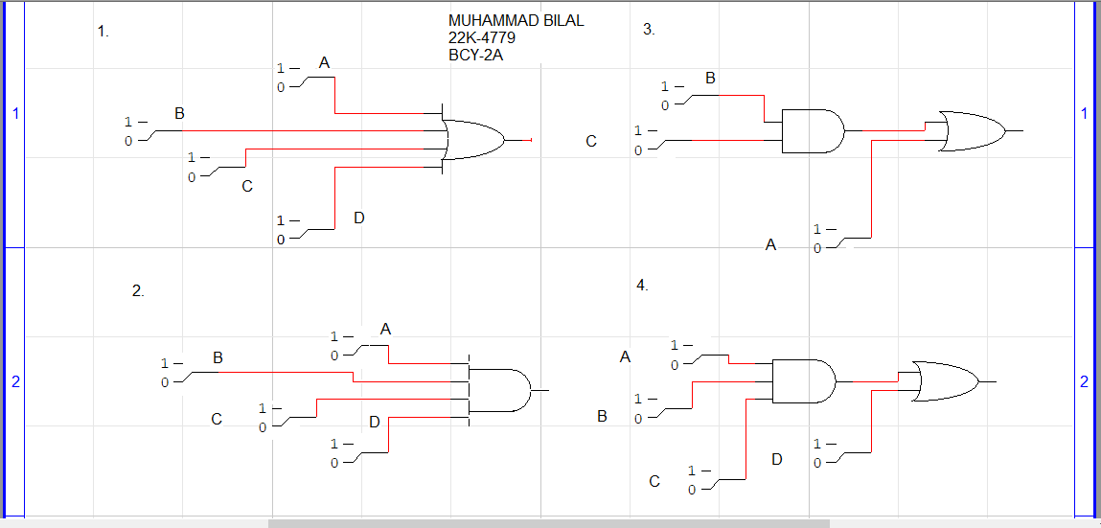

Q1.

|  |  |  |  |
| --- | --- | --- | --- |
| A | C | D | X |
|  |  | | | |  |  |  |
| 0 | 0 | 0 | 0 |
| 0 | 0 | 1 | 0 |
| 0 | 1 | 0 | 0 |
| 0 | 1 | 1 | 0 |
| 0 | 0 | 0 | 0 |
| 0 | 0 | 1 | 0 |
| 0 | 1 | 0 | 0 |
| 0 | 1 | 1 | 0 |
| 1 | 0 | 0 | 0 |
| 1 | 0 | 1 | 0 |
| 1 | 1 | 0 | 0 |
| 1 | 1 | 1 | 0 |
| 1 | 0 | 0 | 0 |
| 1 | 0 | 1 | 0 |
| 1 | 1 | 0 | 0 |
| 1 | 1 | 1 | 1 |
|  | Q2.   |  |  |  |  |  | | --- | --- | --- | --- | --- | | A | B | C | D | X | |  |  |  |  |  | | 0 | 0 | 0 | 0 | 1 | | 0 | 0 | 0 | 1 | 1 | | 0 | 0 | 1 | 0 | 1 | | 0 | 0 | 1 | 1 | 1 | | 0 | 1 | 0 | 0 | 1 | | 0 | 1 | 0 | 1 | 1 | | 0 | 1 | 1 | 0 | 1 | | 0 | 1 | 1 | 1 | 1 | | 1 | 0 | 0 | 0 | 1 | | 1 | 0 | 0 | 1 | 1 | | 1 | 0 | 1 | 0 | 1 | | 1 | 0 | 1 | 1 | 1 | | 1 | 1 | 0 | 0 | 1 | | 1 | 1 | 0 | 1 | 1 | | 1 | 1 | 1 | 0 | 1 | | 1 | 1 | 1 | 1 | 1 | | | | |  |  |  |

Q3.

|  |  |  |  |
| --- | --- | --- | --- |
| A | B | C | X |
| 0 | 0 | 0 | 0 |
| 0 | 0 | 1 | 0 |
| 0 | 1 | 0 | 0 |
| 0 | 1 | 1 | 1 |
| 1 | 0 | 0 | 1 |
| 1 | 0 | 1 | 1 |
| 1 | 1 | 0 | 1 |
| 1 | 1 | 1 | 1 |

Q4.

|  |  |  |  |  |
| --- | --- | --- | --- | --- |
| A | B | C | D | X |
|  |  |  |  |  |
| 0 | 0 | 0 | 0 | 0 |
| 0 | 0 | 0 | 1 | 1 |
| 0 | 0 | 1 | 0 | 0 |
| 0 | 0 | 1 | 1 | 1 |
| 0 | 1 | 0 | 0 | 0 |
| 0 | 1 | 0 | 1 | 1 |
| 0 | 1 | 1 | 0 | 0 |
| 0 | 1 | 1 | 1 | 1 |
| 1 | 0 | 0 | 0 | 0 |
| 1 | 0 | 0 | 1 | 1 |
| 1 | 0 | 1 | 0 | 0 |
| 1 | 0 | 1 | 1 | 1 |
| 1 | 1 | 0 | 0 | 0 |
| 1 | 1 | 0 | 1 | 1 |
| 1 | 1 | 1 | 0 | 1 |
| 1 | 1 | 1 | 1 | 1 |

**Lab Task #3**

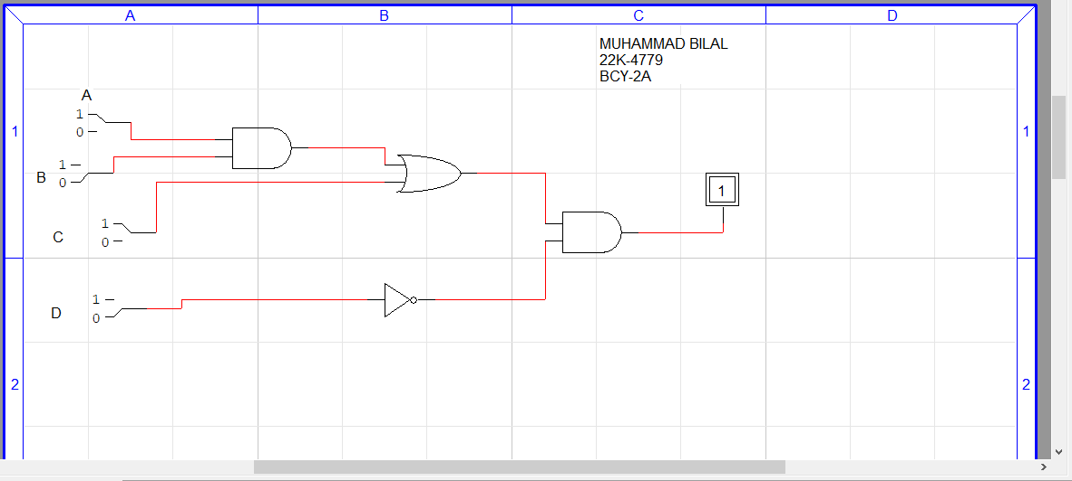

Truth table:

|  |  |  |  |  |
| --- | --- | --- | --- | --- |
| A | B | C | D | X |
|  |  |  |  |  |
| 0 | 0 | 0 | 0 | 0 |
| 0 | 0 | 0 | 1 | 0 |
| 0 | 0 | 1 | 0 | 1 |
| 0 | 0 | 1 | 1 | 0 |
| 0 | 1 | 0 | 0 | 0 |
| 0 | 1 | 0 | 1 | 0 |
| 0 | 1 | 1 | 0 | 1 |
| 0 | 1 | 1 | 1 | 0 |
| 1 | 0 | 0 | 0 | 0 |
| 1 | 0 | 0 | 1 | 0 |
| 1 | 0 | 1 | 0 | 1 |
| 1 | 0 | 1 | 1 | 0 |
| 1 | 1 | 0 | 0 | 1 |
| 1 | 1 | 0 | 1 | 0 |
| 1 | 1 | 1 | 0 | 1 |
| 1 | 1 | 1 | 1 | 0 |